Execute the following Queries by SQL COMMANDS

1. Show all data associated in salgrade table

select \* from SALGRADE;

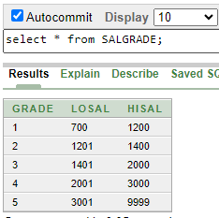

1. Show deptno from dept table

select DEPTNO from DEPT;

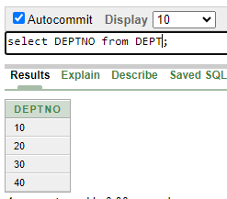

1. Show 5% increment of salary from emp table for each of the employee (ENAME, SALARY, 5% INCREMENT)

select EMPNO, SAL, SAL+SAL\*.05 from EMP;

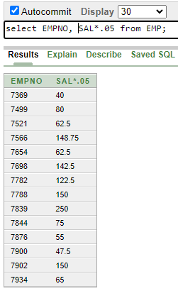

1. Show the new salary after increment (from 3) for each of the employee in emp table

select EMPNO, SAL\*.05 from EMP;

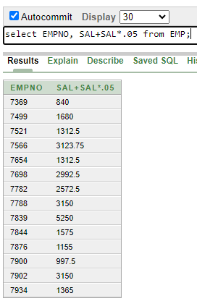

1. Show all the associated information of the employee named “BLAKE”.

select \* from EMP where ENAME = 'BLAKE';

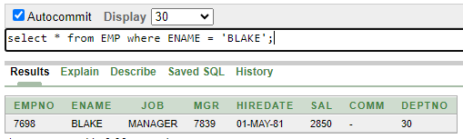

1. Run the SQL COMMAND to show the following output

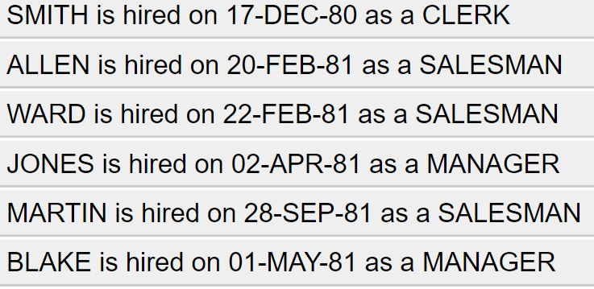

select ENAME || ' is hired on ' || HIREDATE || ' as a ' || JOB from EMP;

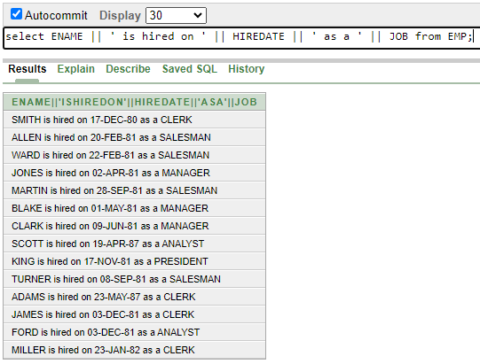

1. Show the description of all the four tables in the scott schema

describe BONUS;

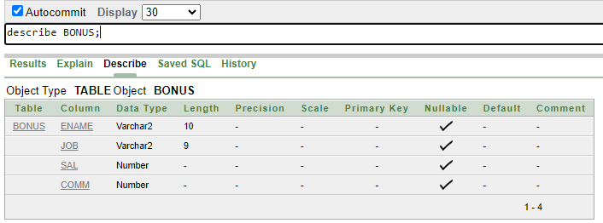

describe DEPT;

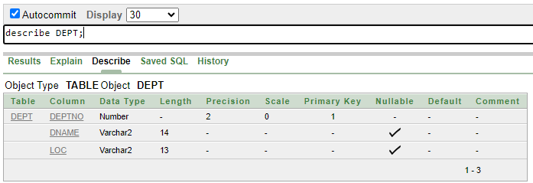

describe EMP;

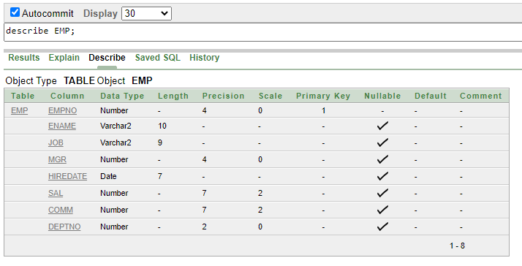

describe SALGRADE;

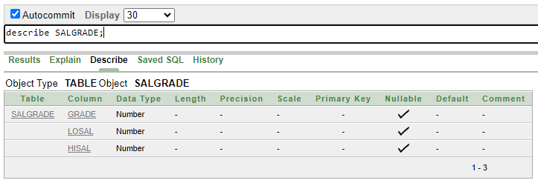

1. Show all the possible jobs from the emp table eliminating the duplicate instances or output

select distinct JOB from EMP;

